**Api -application programming interface**

It is an interface that allow 2 application to talk to each other.

The server interact each other through the Api.

Creating a collection

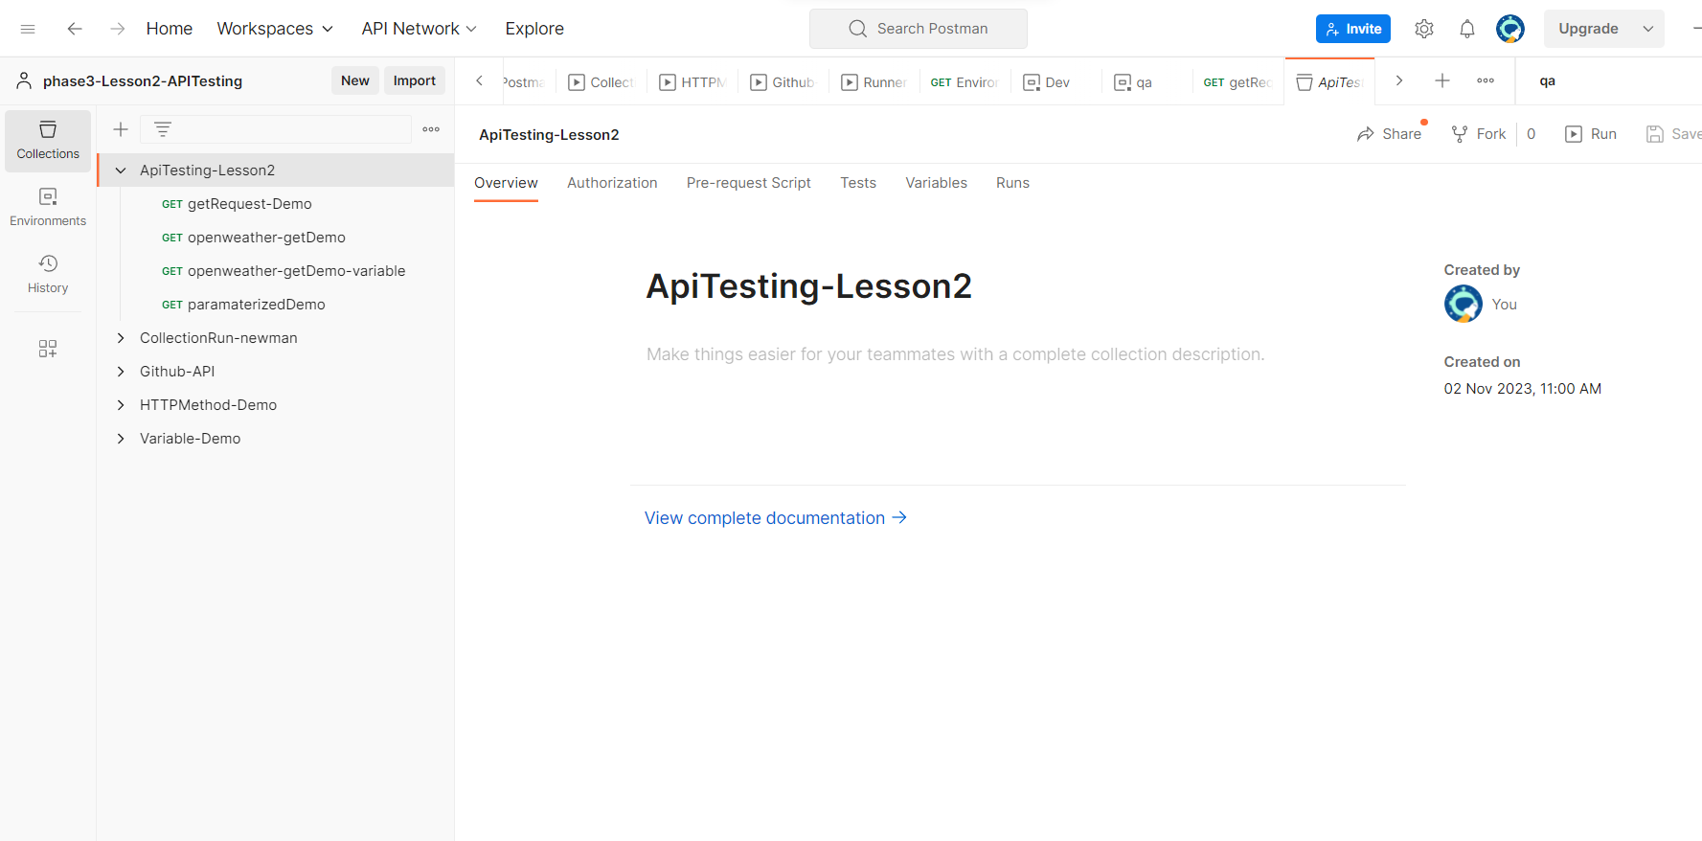

Adding a request

